Installation of STS:  
===============

Download STS from this url :  
[Spring | Tools](https://spring.io/tools)

And unzip the STS downloaded file which location u need STS

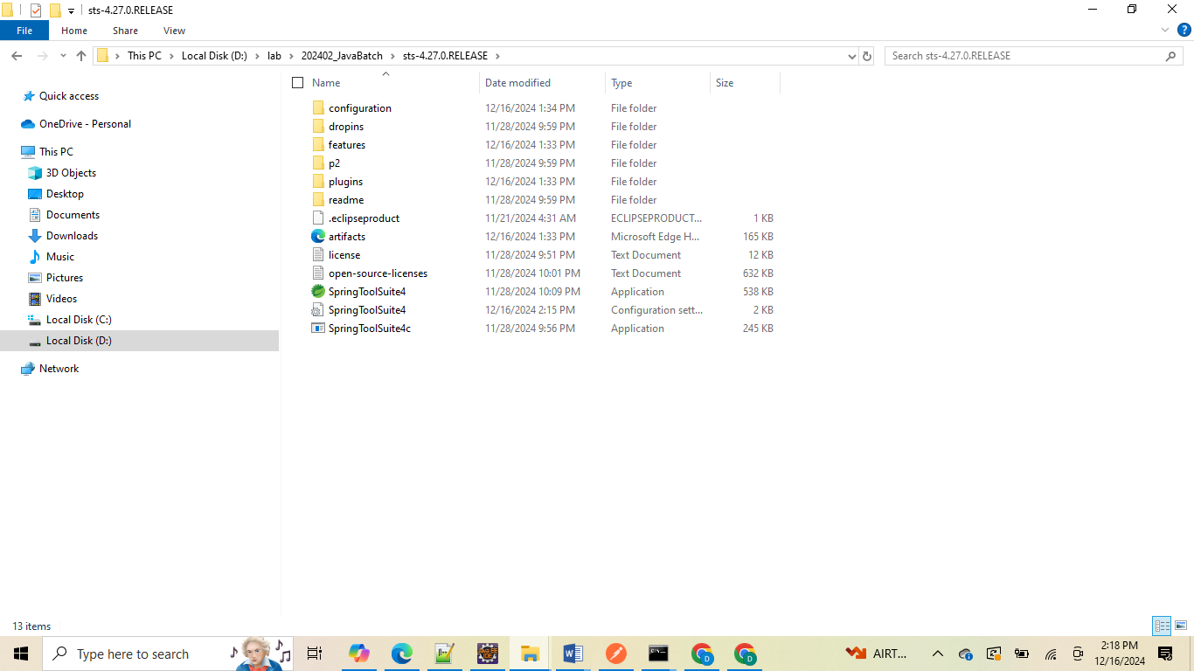

Then click on STS application .exe file with STS logo to open the sts and select work space and create projects which u want same as eclipse and it. STS is mainly designed for Spring framework purpose but internally it works as same as eclipse with extra features for spring boot projects.   
  
by using STS we create Spring boot project form STS only as same as spring initializer web site all options we will get inside sts it self

File -> new project -> Spring starter project ->

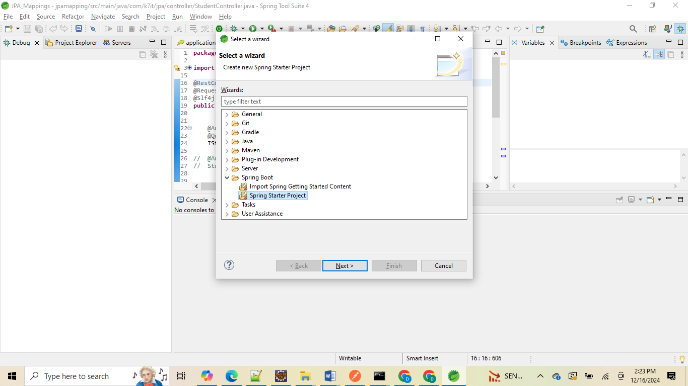

**Click next: then provide project name and package structure and artifact id and select language as Java and java version as 21 or 23 and type is maven or gradle etc info you can select as we have done from Spring initializer. Io web site**

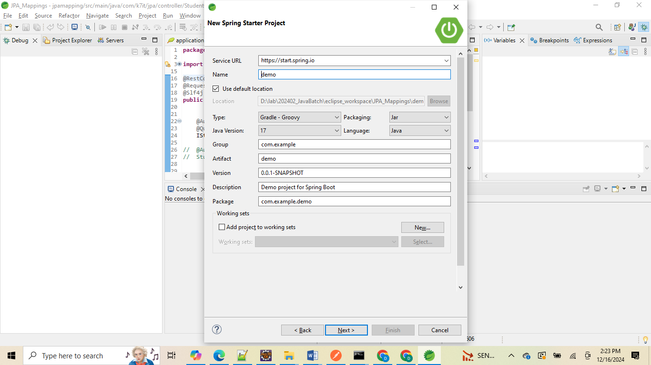

**Then click next we will get new screen for select spring project dependencies list**

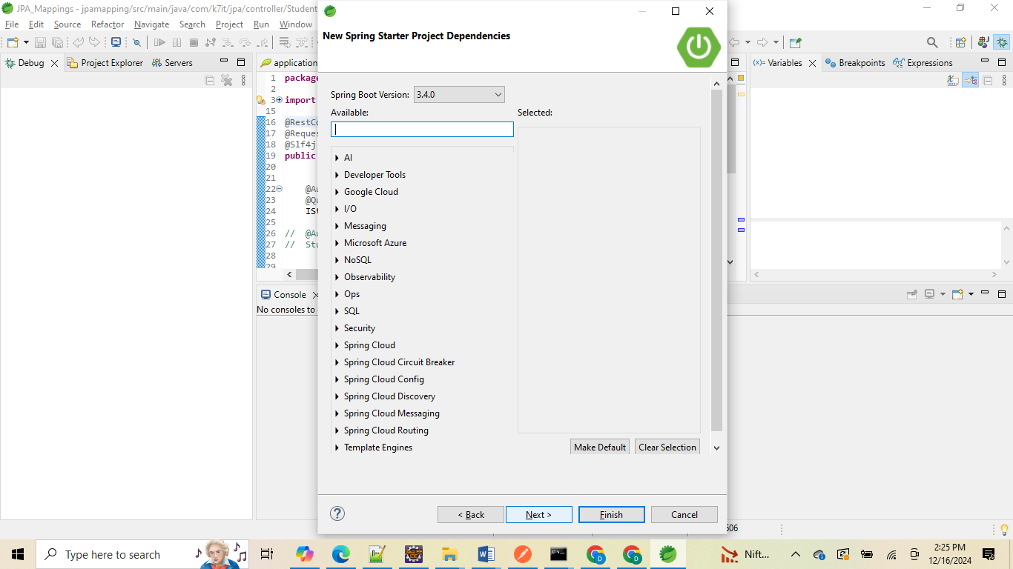

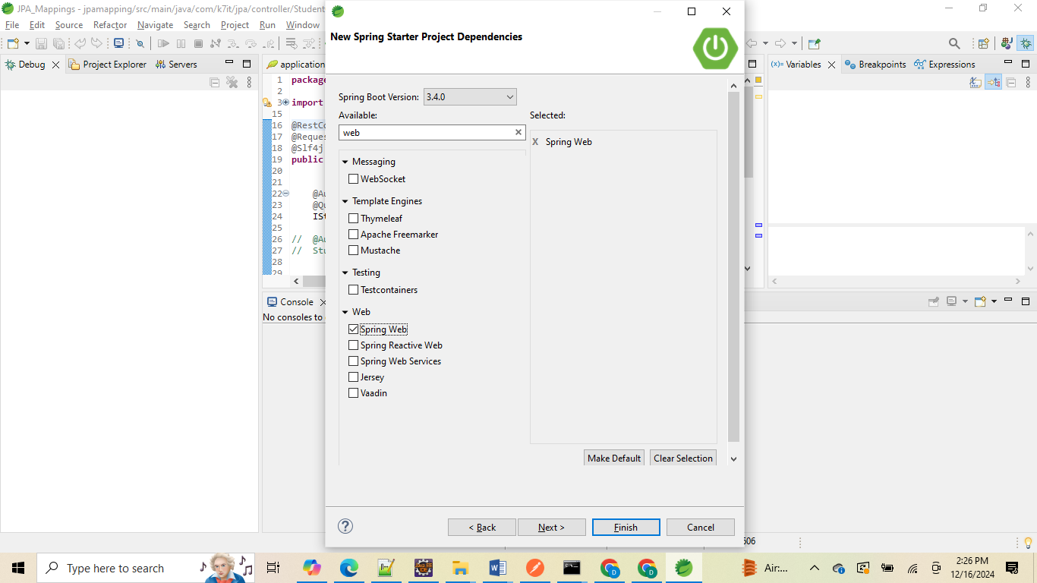

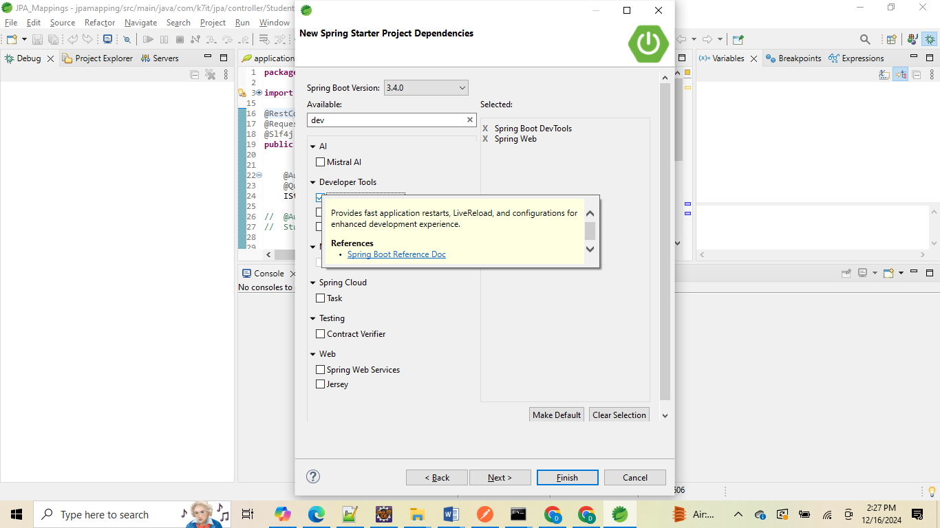

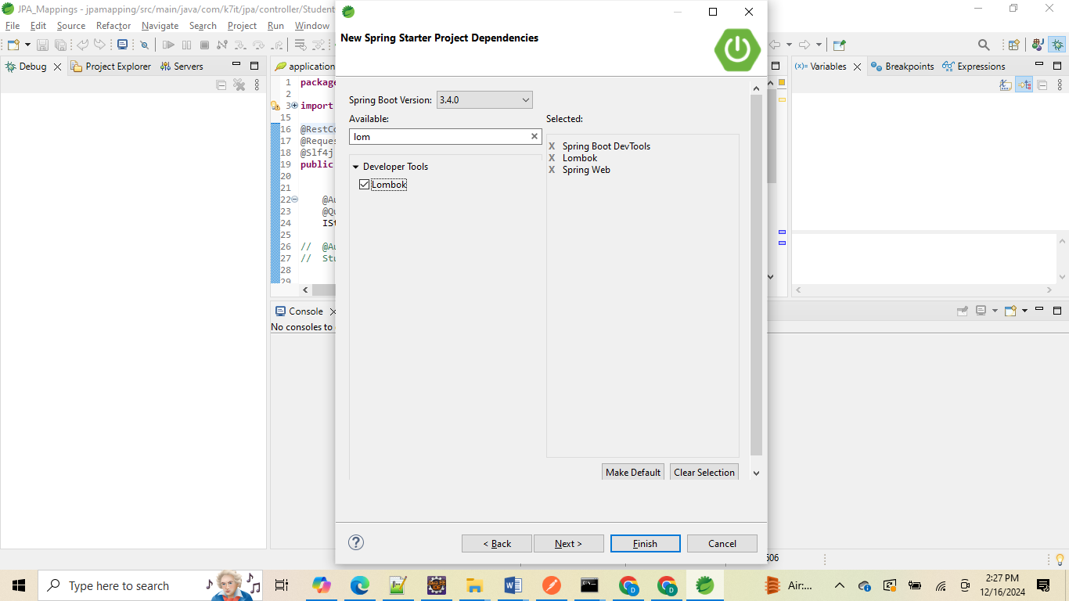

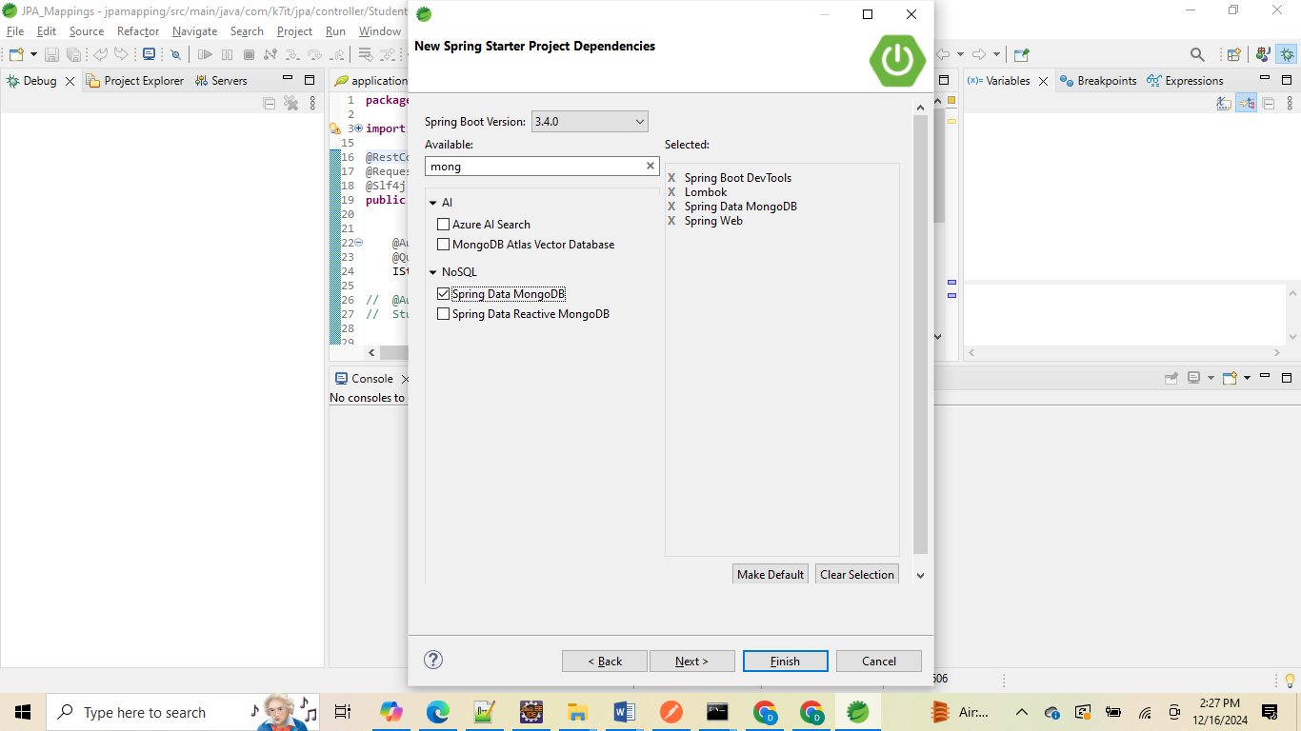

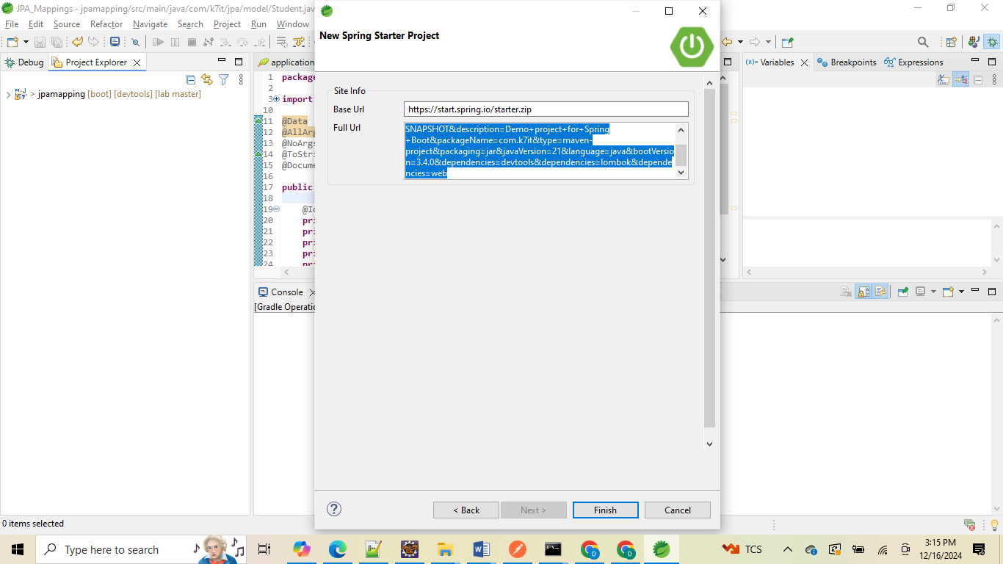

**Here it will call the spring starter api with our input values as Request parameter as a query String format**

<https://start.spring.io/starter.zip?name=demo&groupId=com.k7it&artifactId=demo&version=0.0.1-SNAPSHOT&description=Demo+project+for+Spring+Boot&packageName=com.k7it&type=maven-project&packaging=jar&javaVersion=21&language=java&bootVersion=3.4.0&dependencies=devtools&dependencies=lombok&dependencies=web>

**Like above select required dependencies and click on finish button .**

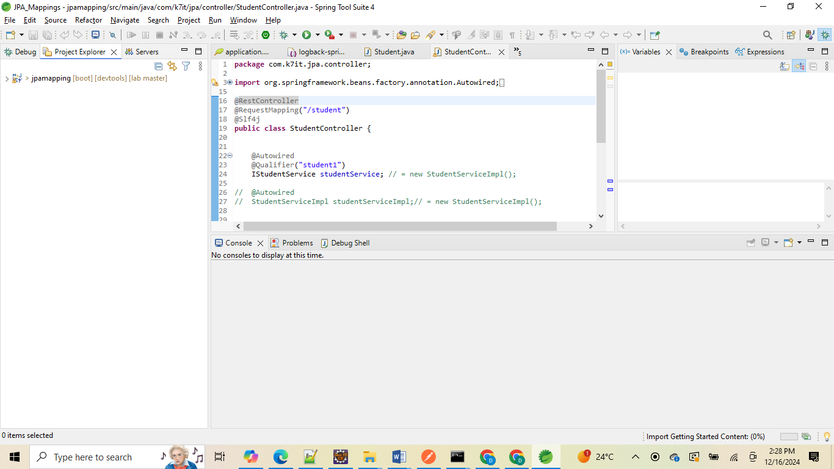

**It will import the project automatically**

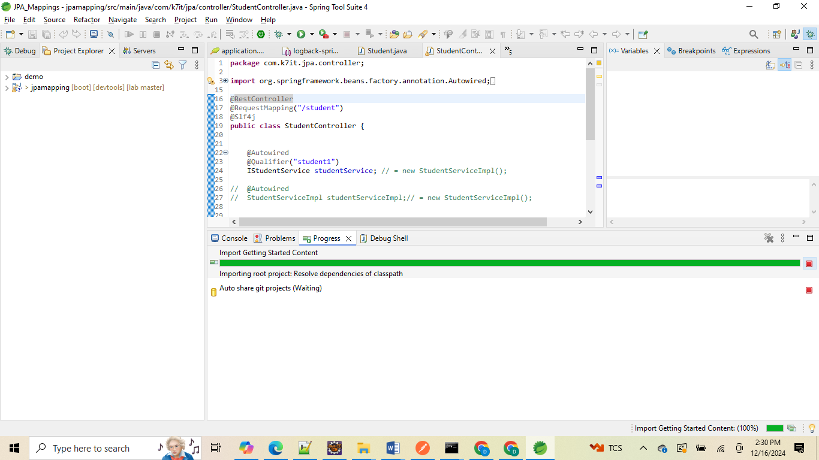

**In case if we want to add any dependencies after creating project we can add like normal maven dependencies like eclipse else we can do like bellow**

**Select project -> rt click -> spring-> add starters**

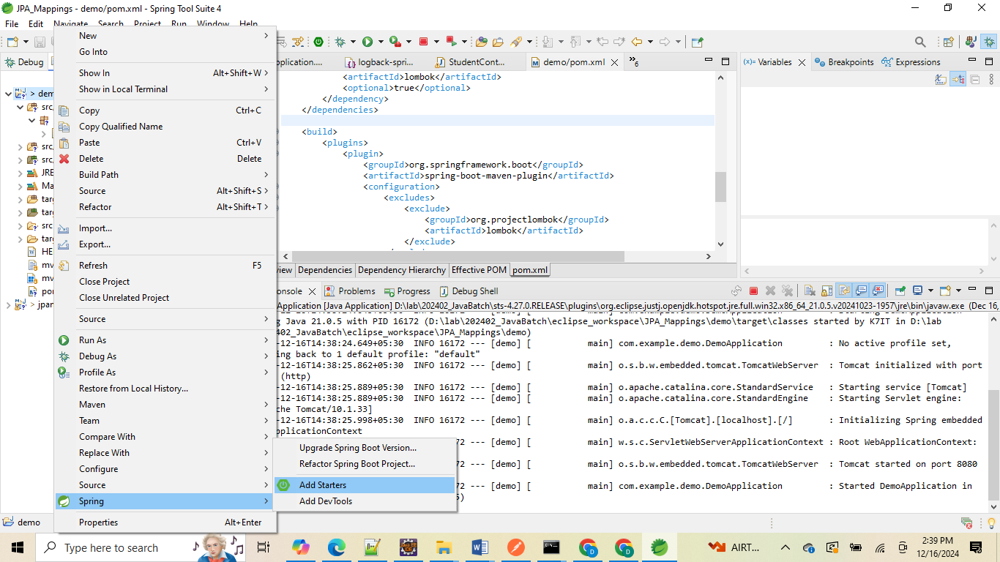

**It will navigate us again into spring boot initializer dependency page like below and add dependencies which we need extra and click one finish**

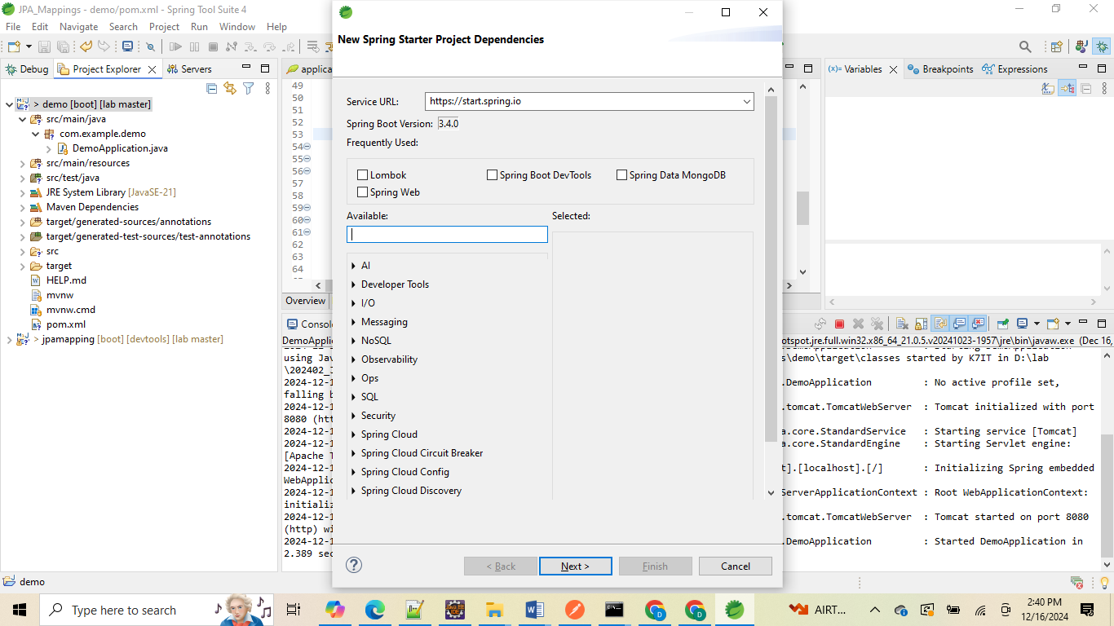

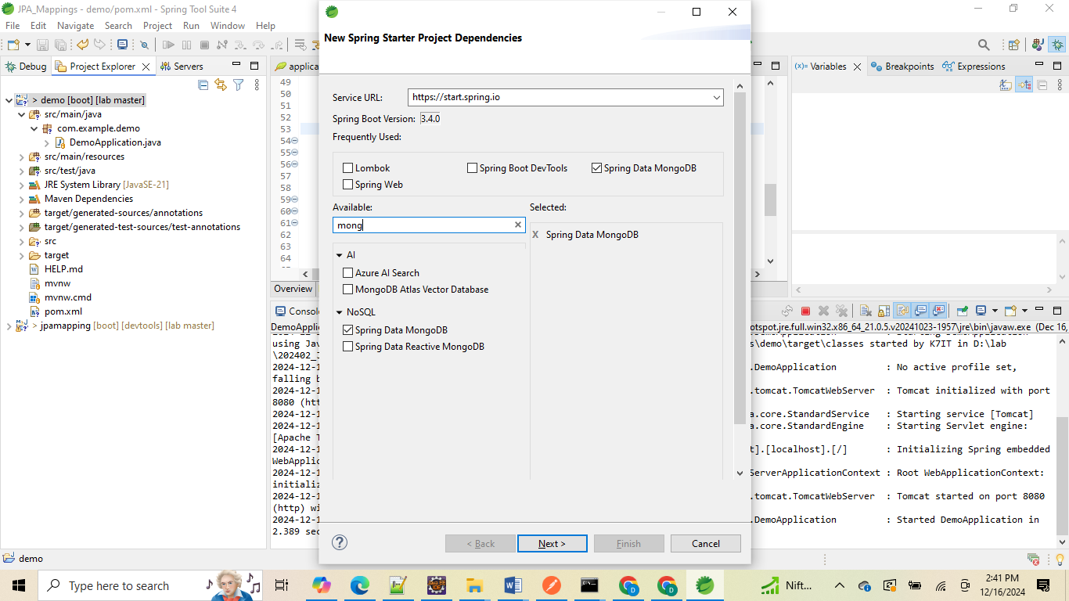

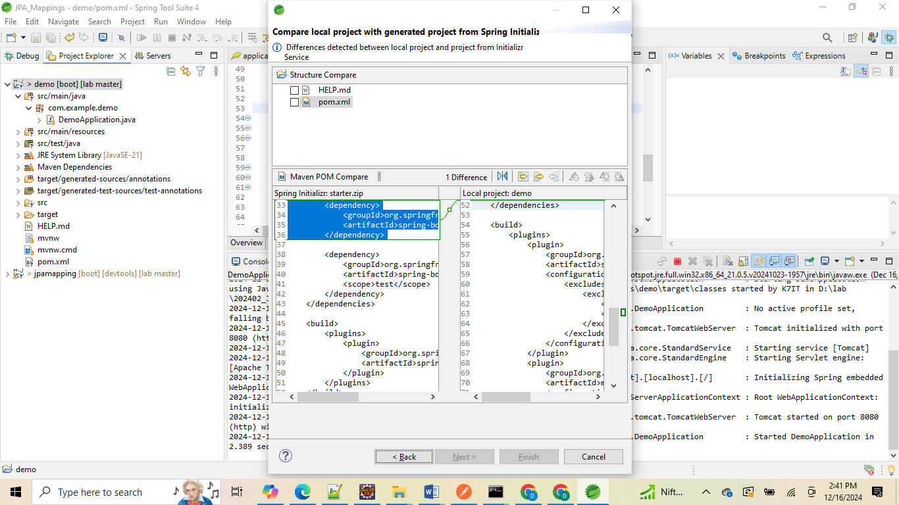

**Then select pom.xml from check box**

**Then click on finish**

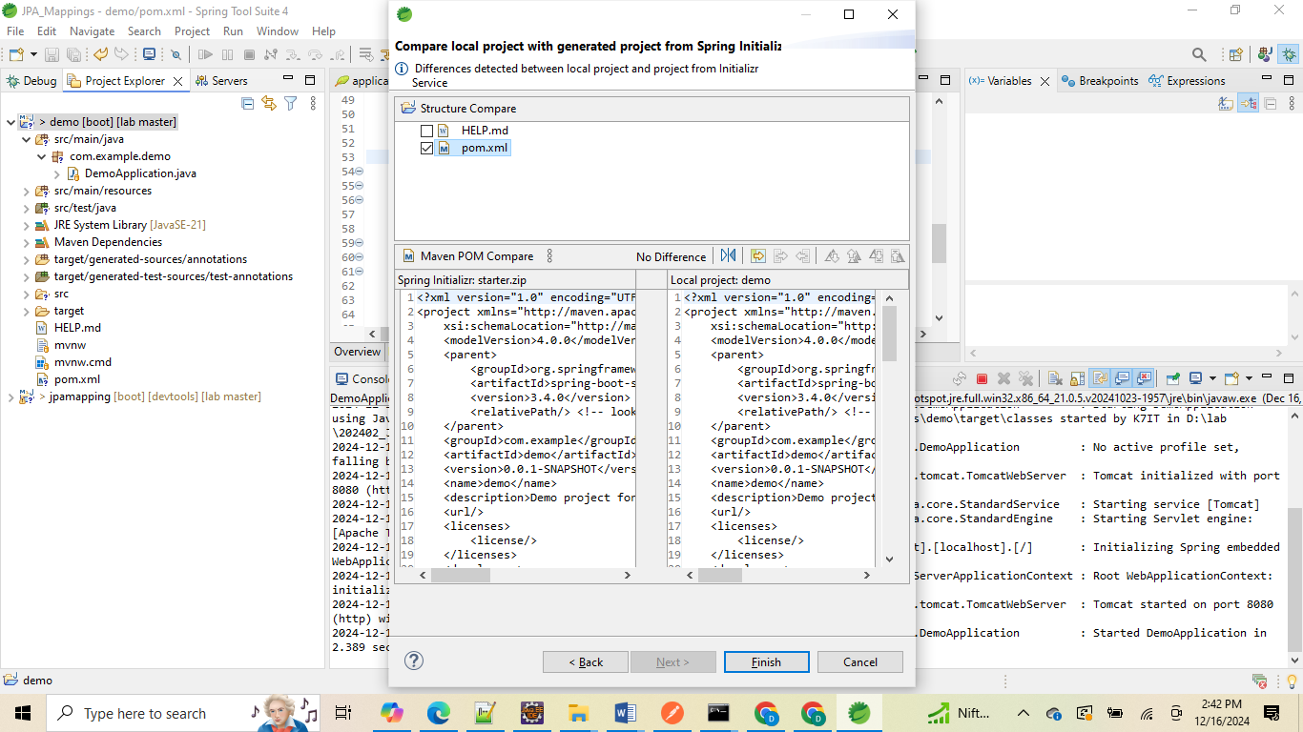

2nd way of enable Lombok plugin from STS:

**Help -> install new software ->**

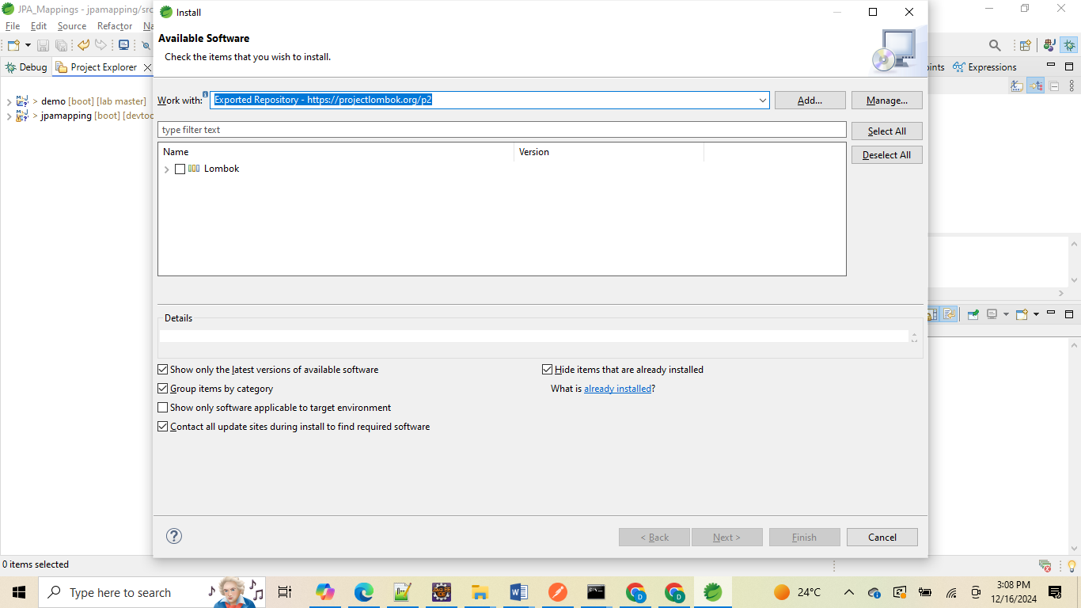

**Then enter this url inside workwith :** [**https://projectlombok.org/p2**](https://projectlombok.org/p2)

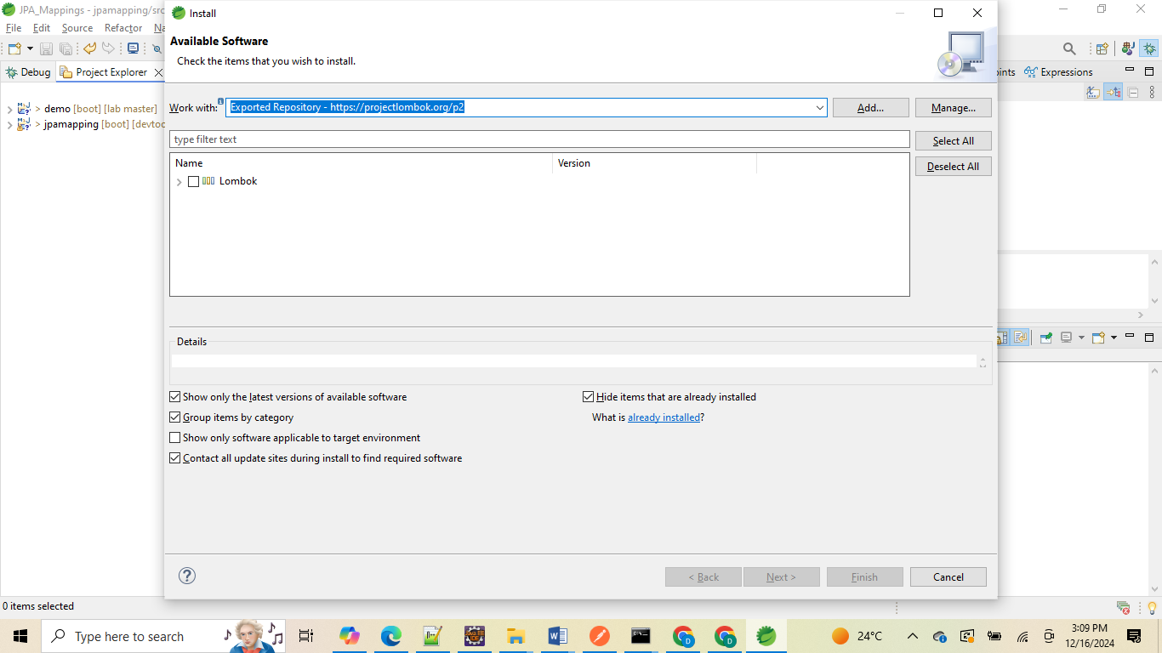

**Then select Lombok check box ->**

**Then accept the license and multiple times it will ask for trusted selection options**

**Then finally finish once it installed it will show like bellow.**

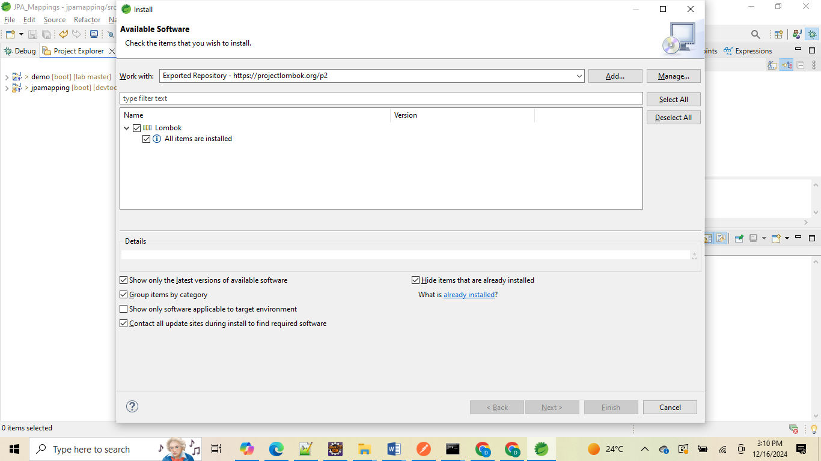

**Restart the STS;**